**Query Folding**

Query folding is a feature of Power Query Editor, that transforms the steps of transformation into a single SQL Query , to Retrieve data from the data source.

Power Query Engine Internally decides which transformation should be folded back into SQL Query and which transformation should be done into the Power Query engine.

Query folding is used to make all possible transformation directly from the data source rather than fetching all data and then making transformation in Power Query.

Query Folding is very important in context of data modeling. There are some reasons given below:

* When using Import mode ,Rather than fetching All data from the data source in memory , only the transformed data is fetched. It makes the performance faster and makes our report more efficient.
* When using Direct Query or Dual Storage mode , All your transformation are based on Power Query query that can be folded back.
* It can also reduce the duration of refresh .

Query folding can be achieved fully or partially , based on the transformation steps . power Query Engine is smart enough to rearrange your steps. And decide which step is folded back .

Data Sources that supports Query Folding:

Most of the Data Sources that uses SQL and other Query Language to query data , can support query folding.

Ex. Relational Databases , OData feeds (including SharePoint lists), Exchange, and Active Directory.

Data sources that contains unstructured data can not support Query folding

Ex : Files , Blob Storage , web.

**Which Transformations Can be Folded ?**

Power Query Engine uses a single SELECT Query to extract data from the data source. So When we transform data , the steps that can be used with select area folded back to the SQL query.

For Ex : Group By , Order By , Rename(using Alias) , JOIN can be used with a SELECT Query.

When we do transformation like Summarizing the table , Grouping the table , Removing columns so these operation can be achieved with direct SQL SELECT Query , that’s why they are folded back.

Generally , these transformation are Query Folded , that are given below :

1. **Removing Columns From Table :**

Removing column transformation can be done by SELECT SQL Query by defining the columns that we want.

1. **Renaming the Columns of Table :**

Renaming column transformation can be done in SELECT Query using Alias.

1. **Filter rows of the Table :**

You can filter the rows of table , by static value or Query Parameters . It can be done in SQL SELECT Query by using Where Clause .

1. **Grouping & Summarizing :**
2. **Expanding record columns**
3. **Non-fuzzy merging of fold-able queries based on the same source (JOIN clause).**
4. **Appending fold-able queries based on the same source (UNION ALL operator).**
5. Pivoting and unpivoting (PIVOT and UNPIVOT operators).

**Transformations that Prevent Query Folding :**

1. Using Custom columns with complex Logic.
2. Merging queries from different data sources
3. Appending queries from different data sources.
4. Adding Index Columns.

**How to know that query folding has done or not?**

In Power Query Editor window , you can determine weather your query is folded or not.

1. Got To Power Query Editor Window.

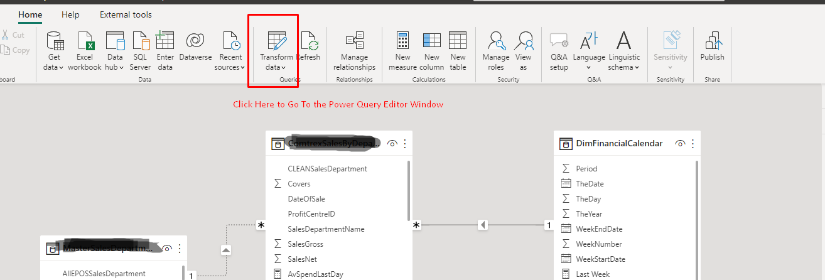

1. In Power Query Editor Window , Click on the View Tab . then Click on the Query Setting Option , to open the Query Setting Pane in Left Side.

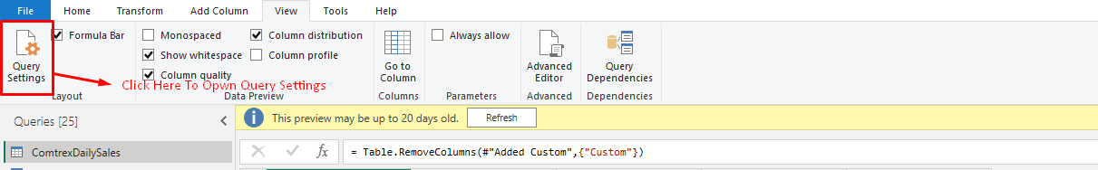

1. In Left Side , a Query Setting Pane has Opened as Given below .

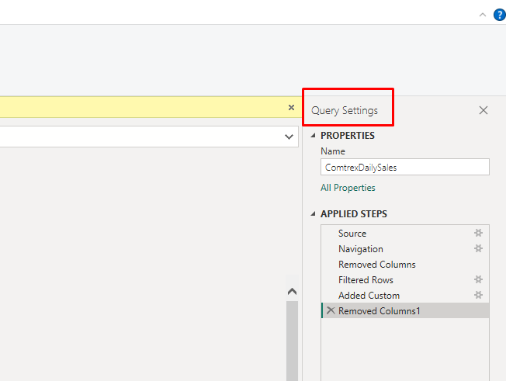

1. In This pane , you can see the transformation steps that you have done in the power query.
2. Right Click on the step , that you want to know weather it is Query folded or not.
3. 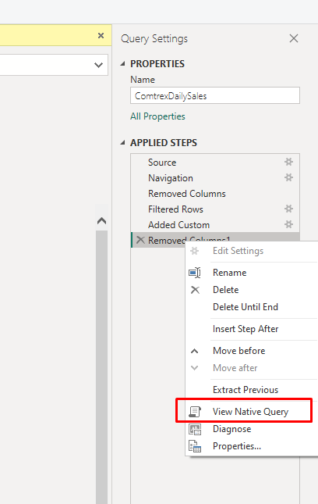
4. if this option is Enable it means query is , folded into SQL Statement. If the option is grayed out , it means the transformation has not been folded.
5. When You click on the View Native Query Option , You can see the SQL SELECT Query that is applied to the data source.

